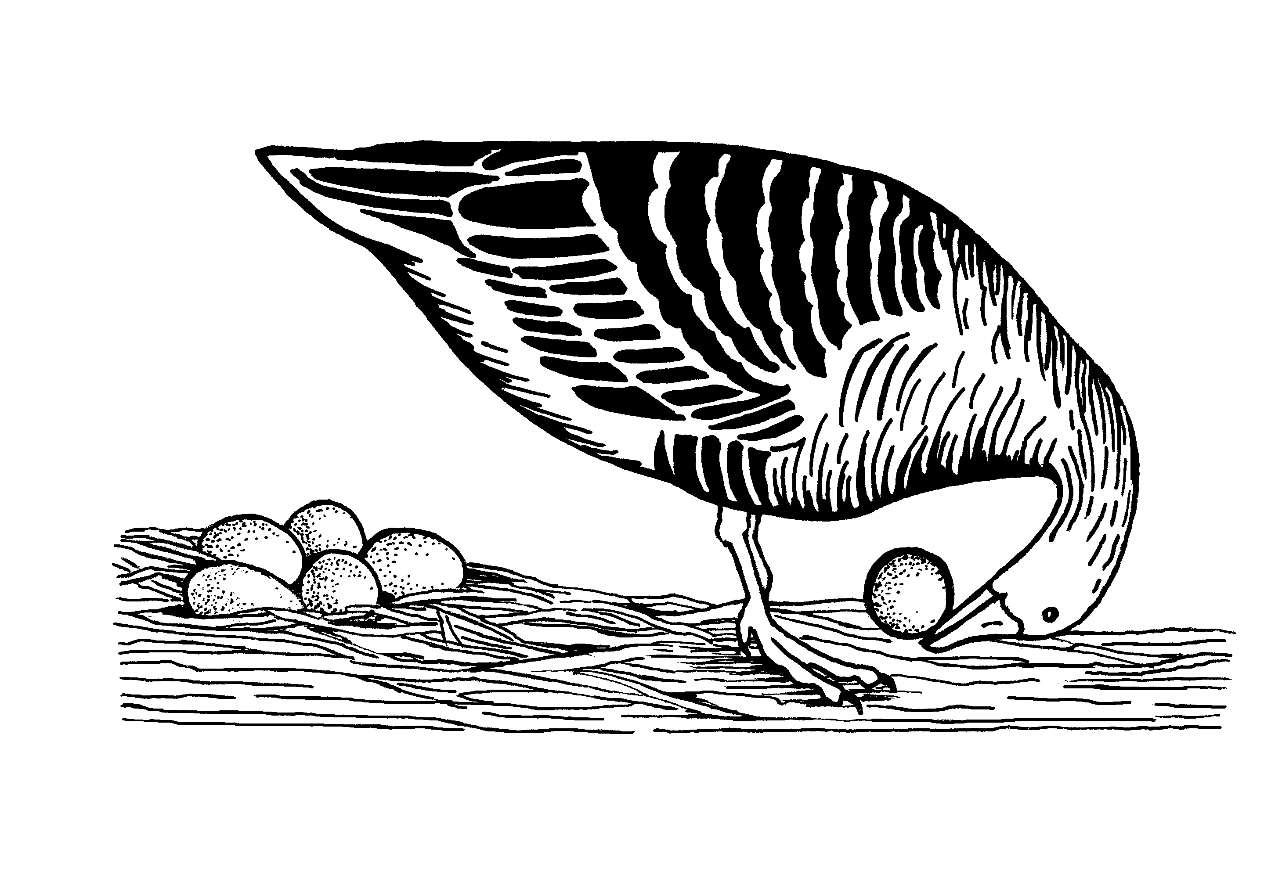
The first (and hopefully last)
virtual conference
of the
Ethologische Gesellschaft e.V.
When? 26.02.2021, 13:00h – 17:00h (MEZ)
Where? Zoom

Registration form
We welcome all researchers of any aspect of ethology. Please submit the completed form by e-mail to info@etho-ges.de. The deadline is 15 January 2021.

Presenter Information

Name:
E-Mail:
Institution:
Society member: ☐ yes; ☐ no; ☐ want to become one! → click here

Attendance

☐ I would like to attend the virtual meeting without a presentation.
Your registration will be confirmed on the 15th of January and you will be sent the Zoom link shortly before the meeting.

☐ I am a student and would like to attend and present my work at the meeting.
Talks will be 5 minutes and can take either the form of a traditional talk or a science slam, where everything is allowed that communicates your science in an entertaining way. The Gwinner Awards will be offered for both categories.

Presentation

Category: ☐ traditional science talk ☐ science slam
Author(s):
Title:
Abstract (max. 2’000 characters)

Please consider my contribution for the Gwinner Award: ☐ yes ☐ no

