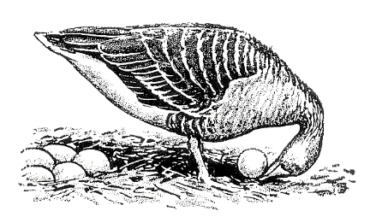
Ethologische Gesellschaft e.V.

SEPA Direct Debit Mandate (SEPA Core Direct Debit Scheme)¹

Will be filled in by treasurer
Creditor Identifier (CI): ........................................................................................................................
Mandate reference: ............................................................................................................................

Account holder:
Last name: ............................................................ First name: .............................................................
Street name: ……………………………………………………… House number: …………………………………………………..
Postal code: …………………………………………….………… City: ……………………..…………..…………………..……………
Financial institute: ………………………………………………………………………………………….………………………………..
BIC: ………………………………………………………………….. IBAN: ……………………………………………………………………

I / we authorize the Ethologische Gesellschaft e.V. to collect payments from my account by direct debit. At the same time, I instruct my credit institute that the Ethological Society or Dr Caspers as treasurer to redeem direct debits drawn from my account.

Name and address of creditor:
Treasurer of the Ethologischen Gesellschaft e.V.
Prof. Dr Barbara Caspers
Universität Bielefeld, Abt. Verhaltensforschung
Konsequenz 45
33615 Bielefeld

Date: ..................................................................... Place: .....................................................................
Signature: …………..………………………………………………………………………………………………………….………………..

Please send the completed form as a PDF to the treasurer of the Ethologische Gesellschaft e.V.:
Prof. Dr Barbara Caspers, Universität Bielefeld, Abt. Verhaltensforschung, Konsequenz 45, 33615 Bielefeld, barbara.caspers@uni-bielefeld.de

¹Data protection is of course guaranteed!

