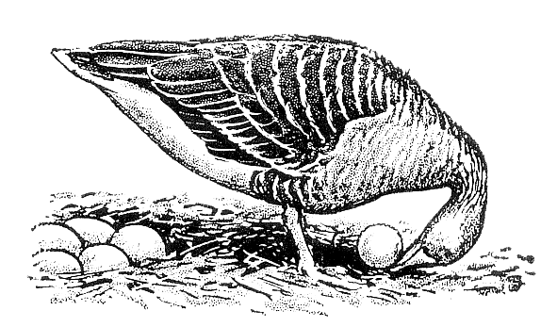
Ethologische Gesellschaft e.V.

Research Grant Application for PhD students

Please complete the following application in the space provided. The application, including references and any supplementary materials, should not exceed the space provided. Font should be no less than 12pt. Please direct any questions regarding your application to Dr Alexander Kotrschal (email: alexander.kotrschal@wur.nl).
Application due: 31 March Date:

Name:
Title of the proposed project:

Institution:
Address:
E-mail:

Summary of proposal (max. 200 words)

3 keywords:

Declaration:
☐ I am an active member of the "Ethologische Gesellschaft" for at least one year.
☐ I will be involved actively in the collection of the data.
☐ I will report on the study in the EthoNews or at the ECBB or one of the societies’ annual meetings within the next two years.
☐ I know that I will have to use the granted money within one year from the date of approval of the grant. Once the project is completed, I will send my research report along with receipts to the treasurer.

Please send this application as ONE PDF document to the grants and awards officer of the Ethologische Gesellschaft (Dr Alexander Kotrschal: alexander.kotrschal@wur.nl).
1. Rationale and significance of this request and how it relates to theory and/or ethology in general (max. 1 page)

2. Hypotheses and predictions (max. 1/2 page)

3. Methods, data and statistics - please be specific (max. 1/2 page)

4. Timeline of the project

5. Budget – Please provide detailed information for all expenditures not to exceed €1’000.00. Do you have additional funds for this project? If so, please list funding sources and amounts.

6. References

7. CV (applicant)

