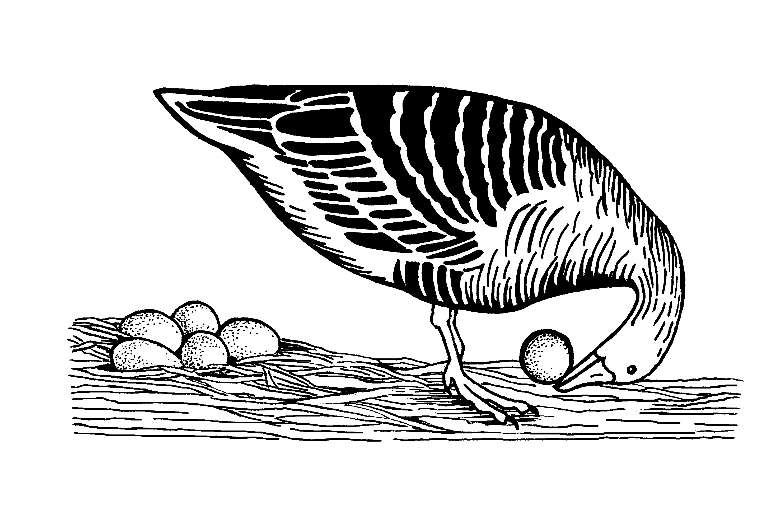
The second (and hopefully last)
virtual conference
of the
Ethologische Gesellschaft e.V.
When? 25.02.2022, 13:00h – 17:00h (MEZ)
Where? Zoom

Registration form
We welcome all researchers of any aspect of ethology. Please submit the completed form by e-mail to info@etho-ges.de. The deadline is 14 January 2022.

Attendance

☐ I would like to attend the virtual meeting without a presentation.
Your registration will be confirmed on the 14th of January and you will be sent the Zoom link shortly before the meeting.

☐ I am a student and I would like to attend and present my work at the meeting.
Talks will be 5 minutes and can take the form of a traditional talk or a science slam, where everything is allowed that communicates your science in an entertaining way. Gwinner Awards will be offered for both categories.

Participant information

Name:
E-Mail:
Institution:
Society member: ☐ Yes; ☐ No; ☐ I want to become one, please click here

Presentation

Category: ☐ Traditional science talk ☐ Science slam
Author(s):
Title:
Abstract (max. 250 words)

Please consider my contribution for the Gwinner Award: ☐ Yes ☐ No

