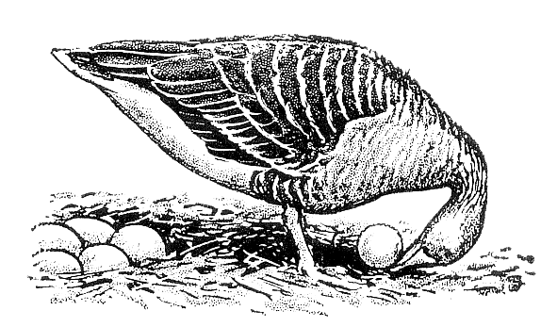
Ethologische Gesellschaft e.V.

Termination of the Ethologische Gesellschaft e.V. Membership¹

Dear Manager of the Ethologische Gesellschaft e.V.,
This is to notify you that I herewith wish to terminate my Ethologische Gesellschaft e.V. membership at the earliest possible date.

Place, date: ……………………………………………………………………………………………………………………..
Name: ……………………………………………………………………………………………………………………..
First name: ……………………………………………………………………………………………………………………..
Membership No: ……………………………………………………………………………………………………………………..
Signature: ……………………………………………………………………………………………………………………..

Please note that according to §4 of the statute of the Ethologische Gesellschaft e.V. (https://www.etho-ges.de/wordpress/rules/), the member must give written notice of termination at least ¼ year before the end of the financial year.

