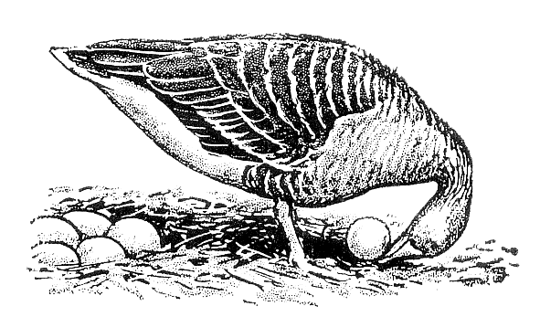
Ethologische Gesellschaft e.V.

Application to become a member of the Ethologische Gesellschaft e.V.¹

Will be filled in by Management
Membership No.: …………………………………………….. Date: ………………………………………………………………

Please fill in the following information:
Last Name: .................................................................. First Name: ......................................................
Title (Prof., Dr, Dipl.-Biol. etc.): ................................... Date of Birth: ....................................................
Gender (female, male, non-binary, prefer not to say): ………………………………………………………………………
Address (Personal or Work): ………………………………………………………………………………………………….…………
...............................................................................................................................................................
...............................................................................................................................................................
Affiliation: …………………………………………………………………………………………………………………………………..……
Phone: ................................................................. E-Mail: .....................................................................

Please select one option:
☐ Full membership fee (€25 per year)
☐ Reduced membership fee (€10 per year) for students or unemployed persons (Please provide respective documents with your application.)

Payment:
Payments should be received no later than 31st January each year. We encourage you to use our SEPA Direct Debit Mandate form to avoid any delays. Alternatively, you can transfer the fees to our bank account (PayPal transactions are possible):
Ethologische Gesellschaft e.V.
Raiffeisenbank im Naabtal eG
Bank Account: 6437753
BIC: GENODEF1SWD BLZ: 75069171
IBAN: DE76750691710006437753

Date: ..................................................................... Place: .....................................................................
Signature: …………………..………………………………………………………………………………………………….………………..

Please send the completed form as a PDF to the manager of the Ethologische Gesellschaft e.V.:
Dr Manon Schweinfurth, University of St Andrews, School of Psychology & Neuroscience, St Mary’s Quad, St Andrews, KY16 9JP, UK, Tel.: +44 1334 463040, Email: ms397[at]st-andrews.ac.uk
¹Data protection is of course guaranteed!

