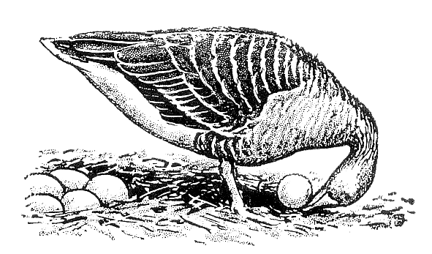
Ethologische Gesellschaft e.V.

Application to become a member of the Ethologische Gesellschaft e.V.¹

Will be filled in by Management
Membership No.: …………………………………………….. Date: ………………………………………………………………

Please fill in the following information:
Last Name: .................................................................. First Name: ......................................................
Title (Prof., Dr, Dipl.-Biol. etc.): ................................... Date of Birth: ....................................................
Gender (female, male, non-binary, prefer not to say): ………………………………………………………………………
Address (Personal or Work): ………………………………………………………………………………………………….…………
...............................................................................................................................................................
...............................................................................................................................................................
Affiliation: …………………………………………………………………………………………………………………………………..……
Phone: ................................................................. E-Mail: .....................................................................

Please select one option:
☐ Full membership fee (€40 per year)
☐ Reduced membership fee (€15 per year) for students or unemployed persons (Please provide respective documents with your application.)

Payment:
Payments should be received no later than 31st January each year. We encourage you to use our SEPA Direct Debit Mandate form (German/English) to avoid any delays. Alternatively, you can transfer the fees to our bank account (PayPal transactions are possible):
Ethologische Gesellschaft e.V.
VR Bank Mittlere Oberpfalz
Bank Account: 6437753; BLZ: 75069171
BIC: GENODEF1SWD
IBAN: DE76750691710006437753

Date: ..................................................................... Place: .....................................................................
Signature: …………………..………………………………………………………………………………………………….………………..

Please send the completed form as a PDF to the manager of the Ethologische Gesellschaft e.V.:
Dr Manon Schweinfurth, University of St Andrews, School of Psychology & Neuroscience, St Mary’s Quad, St Andrews, KY16 9JP, UK; e-mail: ms397@st-andrews.ac.uk
¹Data protection is of course guaranteed!

